|  |  |
| --- | --- |
| **Reg. #** |  |
| **Marks** |  |

**EXPERIMENT # 6**

**Single Phase Controlled Rectifiers**

**Objective:**

Hands-on experience of single phase controlled rectifiers.

**Equipment**

* Lucas Nulle Interface and Experimenters connected to a PC with Labsoft
* Lucas Nulle Power Electronics 1 (SO4203-4D , RLC load Card)
* Connecting wires for Lucas Nulle Equipment

**Controlled Rectification with Resistive Load**

Set up the circuit of a single phase controlled rectifier on Lucas Nulle equipment. A schematic diagram of the rectifier system is shown in Fig. 1. RM1, RM2 and RM3 are 1Ω resistances which may be used for observation of load current waveform on a scope. The Lucas Nulle equipment picture for such a system is presented in Fig. 2.

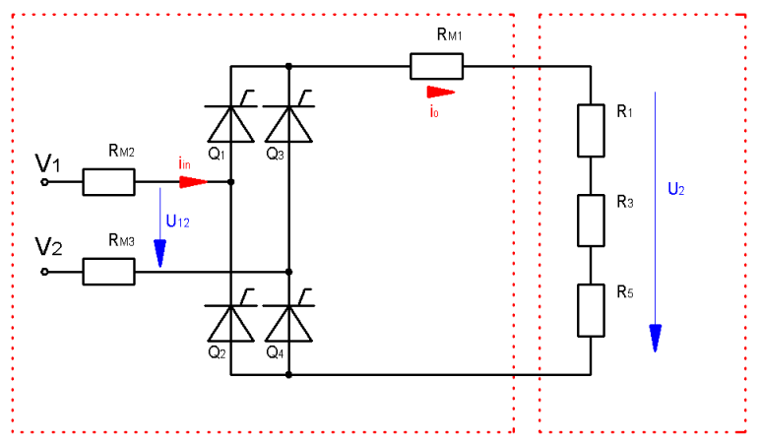

Figure. 1

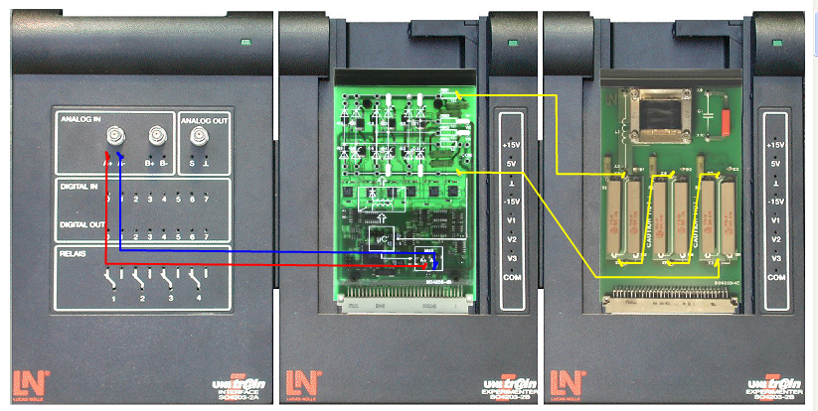

Figure. 2

Select the Timing Diagram Tool from Labsoft. Go to Settings 🡪 Parameters and adjust according to Fig. 3.

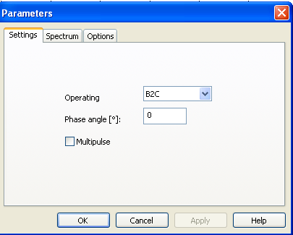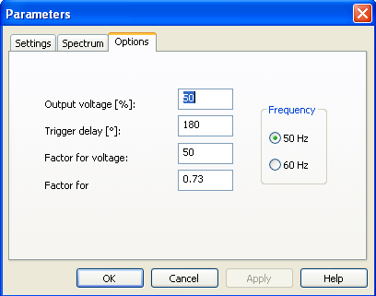

Figure. 3

Double click on the Timing Diagram and select the signals to be viewed as well as their colors. Select input voltage (Red), input current (Blue) and output voltage (Green). Also view the signals Firing Impulse for gates 1 to 4. Then start the measurement by pressing C:\Program Files\LUCAS-NÜLLE\L@BSOFT\BooksENU\1E02\MTI42\images\RunStop.gif in the tool bar. Paste your results in the space above the caption Fig. 4.

Figure. 4

Measure the output DC voltage using a multimeter. Verify the formula for DC output voltage .

|  |  |
| --- | --- |
| Measured Value of Vdc |  |
| Calcualtion of Vdc |  |

Repeat the above (paste graphs as well as measure and calculate dc voltage) for firing angles of 30o , 45o and 90o.

**Controlled Rectification with Inductive Load**

Change the load to an RL load. *Use a single 18 ohms resistance and the* 200mH inductor on the load card. In Labsoft, go to Settings 🡪 Parameters and adjust the output voltage to 75%. Double click on the Timing Diagram and select the signals to be viewed as well as their colors. Select input voltage (Red), output voltage (Blue) and *output current* (Green). Then start the measurement by pressing C:\Program Files\LUCAS-NÜLLE\L@BSOFT\BooksENU\1E02\MTI42\images\RunStop.gif in the tool bar. Paste your results in the space below.

Measure the output DC voltage using a multimeter. Verify the formula for DC output voltage .

|  |  |
| --- | --- |
| Measured Value of Vdc |  |
| Calcualtion of Vdc |  |

Repeat the above (paste graphs as well as measure and calculate dc voltage) for firing angles of 15o and 30o.

|  |
| --- |
| **Write a detailed note on what you have learnt from this lab exercise.**  **________________________________________________________________________________________________________________________________________________________________________________________________________________________________________________________________________________________________________________________________________________________________________________________________________________________________________________________________________________________________________________________________________________________________________________________________________________________________________________________________________________________________________________________________________________________________________________________________________________________________________________________________________________________________________________** |